**Logistic Regression**

**Decision Boundary**

$$h_θ (x)≥0.5→y=1$$

$$h_θ (x)<0.5→y=0$$

$$g(z)≥0.5 when z≥0$$

$$z=0, e^0=1⇒g(z)=1/2 \\ z→ ∞, e^(-∞)→0 ⇒ g(z)=1 \\ z→ -∞, e^∞→∞ ⇒ g(z)=0$$

$$h_θ (x)=g(θ^T x)≥0.5 when θ^T x≥0 \\ θ^T x≥0 ⇒y=1 \\ θ^T x<0 ⇒y=0$$

**Cost Function:**

**Linear regression:**

$$J(θ)=1/m ∑_(i=1)^m▒〖1/2 (h_θ x^((i) )- y^((i) ) )^2 〗$$

**Logistic regression**

$$J(θ)=1/m ∑_(i=1)^m▒〖Cost(〗 (h_θ x^((i) ),y^((i) ) )$$

$$Cost(h_θ x^((i) ),y)= -log⁡(h_θ (x))if y=1$$

$$Cost(h_θ x^((i) ),y)= -log⁡(〖1- h〗_θ (x))if y=0$$

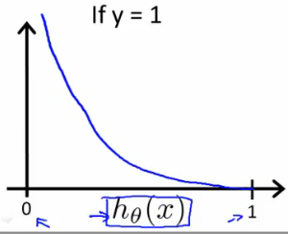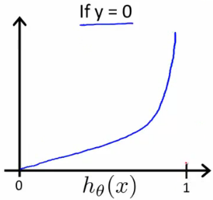

$$Cost\left(h_{θ}x^{\left(i\right)},y\right)= -log\left(h_{θ}\left(x\right)\right)if y=1$$

$$Cost\left(h_{θ}x^{\left(i\right)},y\right)→ ∞ if y=0 and h_{θ}\left(x\right)→1$$

$$Cost\left(h_{θ}x^{\left(i\right)},y\right)→ ∞ if y=1 and h_{θ}\left(x\right)→0$$

**Simplified Cost Function and Gradient Descent**

$$Cost\left(h_{θ}\left(x\right),y\right)= -ylog\left(h_{θ}\left(x\right)\right)-\left(1-y \right)log\left(1- h_{θ}\left(x\right)\right) \\ IF y=1 : Cost\left(h_{θ}\left(x\right),y\right)= -〖log〗⁡(h_θ (x)) \\ IF y=0 : Cost\left(h_{θ}\left(x\right),y\right)= -log\left(1- h_{θ}\left(x\right)\right)$$

$$J(θ)=1/m ∑_(i=1)^m▒Cost(h_θ (x),y) =-1/m[∑_(i=1)^m▒〖y^i log(h_θ (x^i ))+(1-y^i )log(1- h_θ (x^i )) 〗]$$

$$Repeat\{ \\ θj≔θj-α\frac{∂}{∂θ_{j}}J\left(θ\right) \\ \}$$

$$Repeat\{ \\ θj:=θj-\frac{α}{m}\sum_{i=1}^{m}{hθ(x^{i})-y^{i})x_{j}^{i}} \\ \}$$

$$θ:=θ-\frac{α}{m} ​X^{T}(g(Xθ)-y​)$$

**Multiclass Classification: One-vs-all**

$$y ∈\left\{0,1,…,n\right\} \\ h_{θ}^{\left(0\right)}\left(x\right)=P\left(y=0 | x;θ\right) \\ h_{θ}^{\left(1\right)}\left(x\right)=P\left(y=1 | x;θ\right) \\ … \\ h_{θ}^{\left(n\right)}\left(x\right)=P\left(y=n | x;θ\right) \\ prediction= \max_{i}{(h_{θ}^{\left(i\right)}\left(x\right))}$$